**Experiment-1.3**

**Student Name: Milan Sharma UID: 23MAI10003**

**Branch: CSE AIML Section/Group: 23MAI-1**

**Semester: 02 Date of Performance: 08/02/24**

**Subject Name: Research & IPR Lab Subject Code: 23CSP-667**

Aim of the Experiment:

Write an article on topics given below:

a) What are Trademarks and its types.

b) What is a function of trademark.

c) What is the duration of trademark.

d) Flow Chart of Trademark application filing upto acceptance.

**Technical Article:**

**Q1.** What are Trademarks and its types.

Sol. -

A trademark is a distinctive symbol, word, phrase, design, or combination thereof that identifies and distinguishes the goods or services of one party from those of others. Essentially, it serves as a mark of origin, allowing consumers to associate a certain level of quality or characteristics with a specific brand. Trademarks are essential legal tools that help safeguard brand names, logos, and symbols, ensuring that consumers can identify and trust the source of the products or services they choose. In this article, we will explore what trademarks are and delve into the different types that businesses can use to protect their brand assets. Trademarks create brand recognition and trust, making them valuable assets for businesses.

Types of Trademarks:

1. Word Marks:

These are trademarks consisting solely of words or any combination of letters, numbers, and/or characters.

e.g. "Apple" for electronic devices.

2. Design Marks:

Design marks encompass logos, symbols, or any visually distinctive elements.

e.g. The Nike "Swoosh" symbol.

3. Combination Marks:

Combination marks incorporate both words and design elements, offering a comprehensive representation of a brand.

e.g. The McDonald's logo, which includes the golden arches and the company name.

4. Slogan Marks:

Slogan marks protect distinctive catchphrases or taglines associated with a brand.

e.g. Nike's "Just Do It."

5. Trade Dress:

Trade dress protects the visual appearance of a product or its packaging that signifies the source of the product.

e.g. The unique shape of the Coca-Cola bottle.

6. Service Marks:

Service marks are used to identify and distinguish services rather than physical products.

e.g. "American Express" for financial services.

7. Certification Marks:

Certification marks indicate that goods or services meet certain standards or qualifications set by an organization.

e.g. The "Fair Trade Certified" mark.

8. Collective Marks:

Collective marks are used by members of a group or association to identify their goods or services.

e.g. The "Made in Italy" mark used by Italian products.

Trademarks are integral to establishing and maintaining a brand's identity in the business world. Businesses should carefully consider the types of trademarks that best suit their needs and take the necessary steps to register and protect them. By doing so, they ensure that their unique brand assets remain secure and recognizable in the eyes of consumers and competitors alike.

**Q2.** What is a function of trademark.

Sol.-

Trademarks are essential legal tools that help safeguard brand names, logos, and symbols, ensuring that consumers can identify and trust the source of the products or services they choose. In this article, we will explore what trademarks are and delve into the different types that businesses can use to protect their brand assets.

The function of a trademark is to serve as a distinctive identifier of the source or origin of goods or services. Trademarks play several essential roles in the business and legal realms:

Source Identification: The primary function of a trademark is to identify the source or origin of goods or services. When consumers see a trademark, they associate it with a particular brand, company, or product.

Brand Recognition: Trademarks help create brand recognition and awareness. Through consistent use, a trademark becomes a symbol that consumers associate with a specific level of quality, reputation, and characteristics.

Consumer Trust: Trademarks contribute to building consumer trust. When consumers encounter a familiar trademark, they often assume a certain level of consistency and reliability in the associated products or services.

Market Differentiation: In a competitive market, trademarks differentiate one company's products or services from those of others. They provide a unique identity that sets a business apart and helps attract and retain customers.

Marketing and Advertising: Trademarks serve as powerful tools in marketing and advertising. They enable businesses to establish and promote their brands effectively, making it easier for consumers to remember and choose their products or services.

Legal Protection: Trademarks offer legal protection against unauthorized use by competitors. Registered trademarks provide their owners with exclusive rights, allowing them to take legal action against infringement and unauthorized use.

Asset Value: Trademarks contribute to the overall value of a business. A strong and well-protected trademark can become a valuable intangible asset that adds to the business's worth, attracting investors or potential buyers.

Global Expansion: Trademarks are crucial for businesses expanding into international markets. By registering trademarks in different jurisdictions, companies ensure protection against unauthorized use and counterfeiting on a global scale.

Quality Assurance: Trademarks act as a symbol of quality assurance. Consumers often associate a well-known trademark with a certain standard of quality, helping them make informed purchasing decisions.

Communication: Trademarks communicate information about a product or service in a concise and recognizable manner. They convey messages about the brand's values, mission, and positioning in the market.

The function of a trademark is multi-faceted, encompassing identification, differentiation, trust-building, legal protection, and overall brand establishment. A well-managed and protected trademark is a valuable asset that contributes significantly to a company's success in the marketplace.

**Q3.** What is the duration of trademark.

Sol.-

The duration of a trademark can vary depending on the jurisdiction and how the trademark is maintained. In general, there are two main aspects to consider: the initial registration period and the renewal periods.

Initial Registration Period:

In many jurisdictions, when a trademark is initially registered, it is granted protection for a specific period, typically ranging from 10 to 15 years. The exact duration can vary between countries. For example, in the United States, a trademark registration is initially valid for ten years.

Renewal Periods:

To maintain trademark protection beyond the initial registration period, trademark owners are usually required to renew their registrations. Renewal periods also vary by jurisdiction. In some places, renewal may be required every 10 years, while in others, it might be more frequent.

Continuous Use Requirement:

In many jurisdictions, the trademark owner is required to demonstrate continuous use of the mark to maintain registration. Failure to use the trademark for an extended period may result in the loss of protection.

Lifetime of the Mark:

As long as the trademark owner continues to meet renewal requirements and use the mark in commerce, trademark protection can potentially last indefinitely.

International Considerations:

It's important to note that trademarks are generally protected on a country-by-country basis. Registering a trademark in one country does not automatically protect it worldwide. To secure international protection, trademark owners often need to register in each country where they seek protection.

Common Law Trademarks:

In some jurisdictions, common law trademark rights may exist based on actual use of the mark in commerce, even without formal registration. However, these rights may be limited compared to the protections afforded by registered trademarks.

It's crucial for trademark owners to stay informed about renewal requirements and deadlines in the jurisdictions where their trademarks are registered. Failing to renew a trademark in a timely manner or not using the mark in commerce as required by law can result in the loss of protection. Consultation with intellectual property professionals or trademark offices in relevant jurisdictions can provide specific and up-to-date information regarding the duration and maintenance of trademarks.

**Q3.** Flow Chart of Trademark application filing upto acceptance.

Flow Chart –

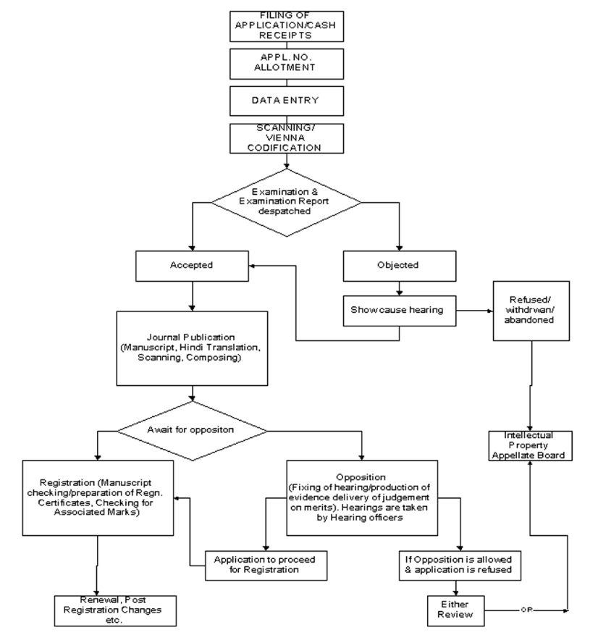

**Viva questions and answers (very short type):**

Q1. What is the purpose of registering a trademark?

Registering a trademark provides legal protection and exclusive rights to the owner. It helps prevent others from using similar marks, reducing the risk of confusion in the marketplace.

Q2. How does a trademark contribute to brand recognition?

A trademark serves as a visual symbol that consumers associate with a particular brand, creating instant recognition and distinguishing it from competitors.

Q3. Name two examples of famous trademarks.

Examples include the Apple logo and the Nike "Swoosh" symbol.

Q4. What is the difference between a word mark and a design mark?

A word mark consists of words or letters, while a design mark includes visual elements like logos, symbols, or graphics.

Q5. How often might a trademark need to be renewed?

Trademarks often need to be renewed every 10 years, but the renewal period can vary depending on the jurisdiction.

Q6. What does a certification mark signify?

A certification mark indicates that goods or services meet specific standards or qualifications set by an organization.

Q7. Explain the term "trade dress" in trademarks.

Trade dress protects the visual appearance and overall image of a product or its packaging, helping consumers identify the source.

Q8. In what situations might a slogan be protected as a trademark?

A slogan may be protected as a trademark when it is distinctive and associated with a specific brand, helping consumers recognize and identify the source of goods or services.

**Learning Outcomes:**

1. Learned about Trademarks, Design Trademark etc.
2. Learned about function and uses of Trademark.
3. Learned how to get our own trademark and process related to it.